[unning Castle Blackmoor – Part 8: Special Interest Experience](https://thealexandrian.net/wordpress/40942/roleplaying-games/running-castle-blackmoor-part-8-special-interest-experience)

October 17th, 2018

[Go to Part 1](https://thealexandrian.net/wordpress/40789/roleplaying-games/running-castle-blackmoor)

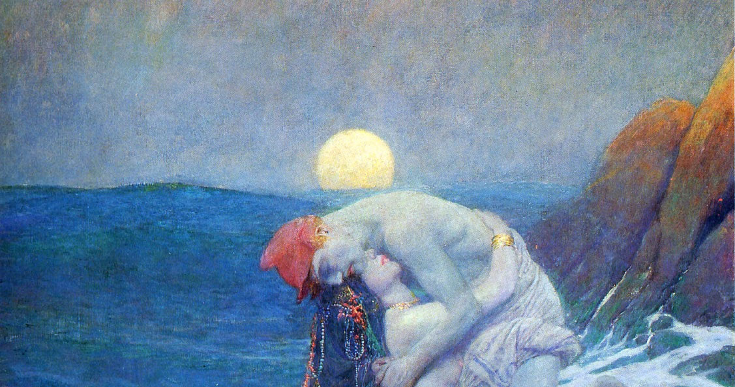

In the [First Fantasy Campaign](http://www.amazon.com/exec/obidos/ASIN/B000JISJRY/digitalcomi0a-20), Dave Arneson includes a system of “Special Interests” of which he writes, “Instead of awarding points for money and Jewels acquired in the depths of the Dungeon or hoarding items against the indefinite future, the players will receive NO points until they acquire the items listed below…”

What’s somewhat murky, in my opinion, is exactly what the provenance of this system is. Was it used from the very beginning? Implemented pre-D&D? Implemented as a post-D&D revision? The phrasing seems to suggest that that this system should be used as an alternative to “acquiring” or “hoarding” wealth, which only makes sense as a reaction to such a system already existing. But was that phrasing part of the original notes? Or was it added by Arneson in 1977?

And how was it used in actual practice (if it ever was; although, unlike Gygax, Arneson’s MO doesn’t seem to have included writing up elaborate rules he never used)? The most extreme interpretation is that experience points were ONLY awarded for spending gold pieces on special interests. The less extreme interpretation would be that this system is only meant to “replace” the current wealth-based XP system, while leaving the monster-slaying portion of the XP system intact.

Perhaps Daniel Boggs’ exploration of the [Richard Snider Variant](http://boggswood.blogspot.com/2018/09/almost-forgotten-published-rpg-ruleset.html) can shed some light on this.

For the purposes of running Castle Blackmoor, as you’ll see below, I’ve decided to go with the most extreme interpretation: The only way to gain XP is to pursue your special interests. (This is, again, not a declaration that I believe this to have been what was happening at Arneson’s table circa-1971. It’s just the most interesting choice to make as we explore alternative play dynamics.)

Unfortunately, the system as published in the First Fantasy Campaign is more or less unusable as it appears in print, including tables that are not explained, alternative generation methods which are described as being roughly equivalent but actually produce radically different results (suggesting that their explanation has either been mangled or that the material is actually an inchoate mash-up of several different revisions of the ruleset), multiple “examples” that all contradict each other and any version of the rules, and copious references to other sub-systems that have simply not been included.

As a result, the system below can be described, at best, as being inspired by the best ideas in Arneson’s system, liberally fleshed out with my own ideas. For example, the racial special interests are wholly mine as are all of the caravan guidelines (although not the idea of goods being brought in by caravan) and the hobby project rules, these latter being heavily influenced by [Blades in the Dark](https://thealexandrian.net/wordpress/40484/roleplaying-games/blades-in-the-dark-system-cheat-sheet) because Arneson provided no meaningful mechanical insight for this and I didn’t feel like there was value in reinventing the wheel (pun intended).

GENERATING SPECIAL INTERESTS

* + Roll 1d8 to determine a random Special Interest. Your character will have a 100% rating in this Special Interest.
  + Add your Racial Special Interest (see below).
  + For all other Special Interests, roll 2d6 x 10% to determine their rating.

|  |  |
| --- | --- |
| D8 | SPECIAL INTEREST |
| 1 | Carousing |
| 2 | Song/Fame |
| 3 | Religion/Spirituality |
| 4 | Philanthropy |
| 5 | Carnavale |
| 6 | Hoarding |
| 7 | Training |
| 8 | Hobbies |

GAINING EXPERIENCE POINTS

* + You only gain XP for GP which are taken out of the dungeon and spent on a Special Interest.
  + XP is gained on a 1-for-1 basis modified by the character’s rating in the Special Interest. (For example, if you have an 80% rating in Philanthropy and you donate 1,000 GP, you would gain 800 XP. If you have a 120% rating in Carousing and spend 100 GP at the bar, you would gain 120 XP.)

COMPLICATIONS

* + Spending GP on a Special Interest may lead to complications. For some Special Interests, these complications will be generated randomly. In other cases, they can be avoided with a saving throw (as indicated in the Special Interest description). Use a 1 in 6 chance unless specified otherwise.
  + If a complication is generated, roll on the complications table for that Special Interest. [Note: Until these complication tables are generated, complications will be at the GM’s discretion.]

COMMUNITY LIMITS

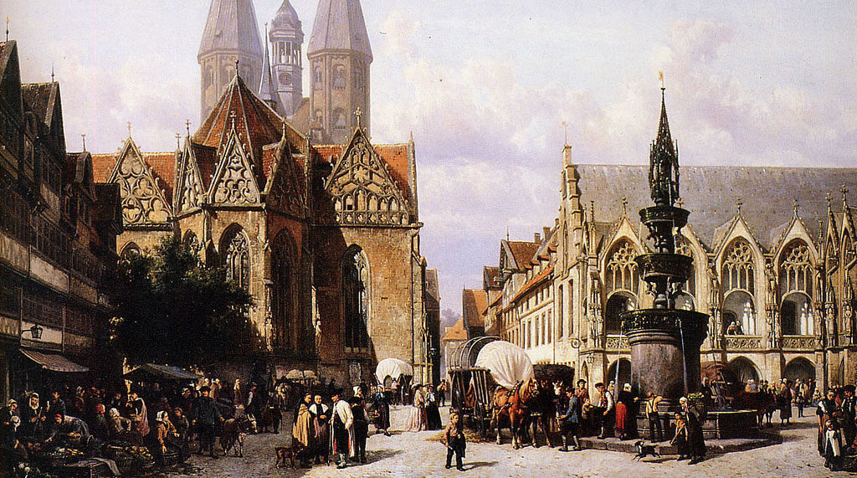

* + The size of the community that you’re pursuing your Special Interest in will limit the amount of money you can spend on a Special Interest per quiescence.
  + This limit is per character (i.e., Lynmae could spend the community’s full GP limit for Carnavale, but that wouldn’t prevent Derk from doing the same).
  + The limit is also per Special Interest category. (If Lynmae has spent all the GP she can on Carnavale for this quiescence, she can still spend additional GP on Carousing.)
  + The community’s base value is often modified by specific Special Interests, as noted in their descriptions. Some communities might also have higher-than-usual or lower-than-usual limits for specific Special Interest categories or activities, and community investment will also change the values the GP limit of the town for different Special Interest categories (see below).
  + Wards: Alternatively, the GM might model large cities and metropolises as a collection of wards. Each individual ward can be given customized GP limits and complication tables, reflecting the differing character of each section of the city. PCs who have “exhausted” one ward can simply continue their spending in another ward.

|  |  |  |
| --- | --- | --- |
| COMMUNITY | POPULATION | GP LIMIT |
| Thorpe | 20 | 1d6 x 10 |
| Hamlet | 200 | 1d6 x 50 |
| Village | 1,000 | 1d6 x 100 |
| Town | 5,000 | 1d6 x 250 |
| City | 25,000 | 1d6 x 1,000 |
| Metropolis | > 25,000 | 1d6 x 10,000 |

Quiescence: By default, this term is a synonym for the downtime between sessions played. (In other words, if you go back to the dungeon your spending limits will be reset.) The GM may decide to set the quiescence to a particular time period (a month, for example), or set a particular time period as a minimum (so that if, for example, a player goes many months between sessions played, they may be able to spend many times the normal community limit representing their character’s activities during that time).

BLACKMOOR – BASE LIMITS

* + Base GP Limit: 1d6 x 100 GP
  + Great Kingdom Caravans: 1d6 x 10000 GP limit. 10 + 2d6 days to arrive.

For the purposes of my open table (at least for the moment), I chose to simply abstract the origin point of all caravans as being the Great Kingdoms to the south. This is not dissimilar from what Arneson describes, with players simply needing to meet the caravans at the “edge of the board” and escorting them in town. (Because they were playing on the map of Avalon Hill’s Outdoor Survival game.)

CARAVANS

Expenditures larger than the community’s GP limit can be made by sending a purchase request to a nearby community. (This purchase is, of course, limited by the other community’s GP limit.)

* + Time: The GM should calculate the amount of time it takes for the caravan to arrive (remembering to include the time it takes for the order to arrive and for the requested goods to be assembled). The PC does not gain XP from the GP spent until the caravan arrives.
  + Cost: Caravans charge 10% of the GP value of the order. (This expenditure does not grant XP.)
  + Collective: Multiple PCs can collectively ship their supplies on a single caravan.
  + Community Stimulus: When large amounts of material are shipped into a community, it stimulates the local economy. When a caravan shipment larger than the community’s maximum GP limit in a category arrives, apply 1% of the difference to improve the GP limit of the community (as per a community investment).

Caravans – Jeopardy: Caravans are subject to brigandry, natural disasters, and eldritch fates of an even stranger character. In some cases, characters might also simply be scammed by unethical caravan masters who simply abscond with their funds.

* + Basic: To quickly determine the fate of a caravan, simply roll on the Basic Caravan Jeopardy table. If goods have been captured, it may be possible to recover them from the lair of whatever bandits, robber barons, or creatures were responsible. (Generate randomly.)
  + Hexcrawl: If the campaign includes a full hexcrawl, the GM can simply track the actual movement of the caravan (generating random encounters as usual and adjudicating the outcomes of those encounters to determine the caravan’s fate).
  + Trail/Road: As caravans will usually follow the same trade routes (whether by road or otherwise), similar results can be achieved without generating a full hexcrawl: The GM can develop each route as a trail, with landmarks along the way and appropriate random encounter tables.

|  |  |
| --- | --- |
| D10 | BASIC CARAVAN JEOPARDY |
| 1 | Vanishes without a trace |
| 2-3 | Goods captured, but might be recovered (+1d10% loss of value per day) |
| 4-10 | Caravan arrives safely |

Caravans – Protecting: If PCs decide to travel with the caravan in order to protect it, roll on the Basic Caravan Jeopardy table normally. The PCs, of course, will have a chance to directly respond to the dangers encountered by the caravan.

* + Mercenaries: PCs can pay additional funds to hire men-at-arms to beef up the caravan’s security. (This expenditure does not grant XP.) In the basic jeopardy system, these forces provide a modifier to the Basic Caravan Jeopardy roll. (There is always at least a 1 in 10 change of the caravan going astray.) Continue rolling and resolving events until “Arrives Safely” result is generated.

|  |  |
| --- | --- |
| MERCENARY MODIFIER | COST |
| +1 | 5 GP per day's travel |
| +2 | 25 GP per day's travel |

COMMUNITY INVESTMENT

PCs may be interested in improving their community. They can do so by spending GP on community investments.

* + Community Investments are generally targeted at a specific Special Interest category, but in some cases the GM may rule that a particular investment would have a positive impact across several categories (in which case its value is divided across those categories).
  + GP spent on community investments do not grant XP, but the base value of the GP Limit of the targeted category is increased by 5% of the investment. (For example, Blackmoor has a base GP limit of 1d6 x 100 for Carousing. If someone makes a 1000 GP community investment in opening a new tavern, the village’s GP limit for Carousing would increase by 50 to 1d6 x 150.)
  + The community investment system is abstract. Players are encouraged to explain where their investment is going and what tangible results it has. (A new wing at the School for Young Wizards? Improvements at the gladiatorial arena?)

Джерело: <<https://thealexandrian.net/wordpress/40942/roleplaying-games/running-castle-blackmoor-part-8-special-interest-experience>>

[Running Castle Blackmoor – Part 9: Special Interests](https://thealexandrian.net/wordpress/40950/roleplaying-games/running-castle-blackmoor-part-9-special-interests)

October 22nd, 2018

[Go to Part 1](https://thealexandrian.net/wordpress/40789/roleplaying-games/running-castle-blackmoor) – [Go to Special Interest Rules](https://thealexandrian.net/wordpress/40942/roleplaying-games/running-castle-blackmoor-part-8-special-interest-experience)

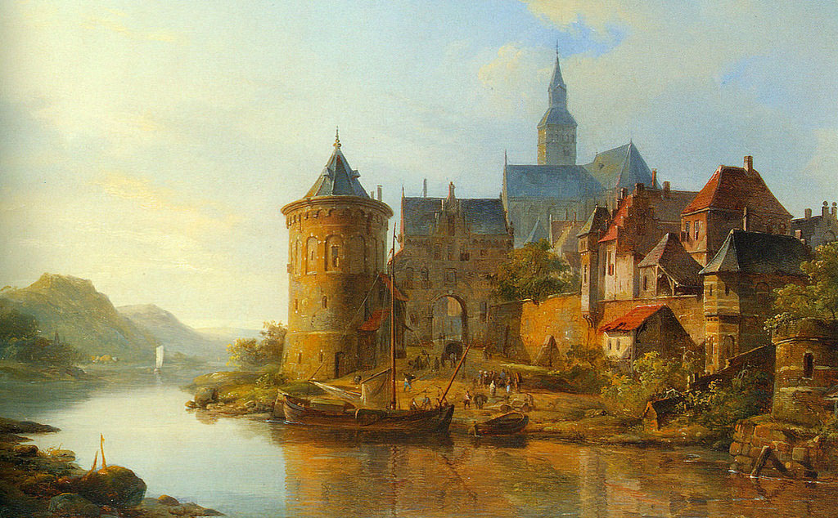

Carousing: Includes drinking, gambling, lusting, entertainment, drugs, fine dining, and all manner of merriment. A good carousing can last the better part of a week. Characters with high Constitution scores can keep going longer than their comrades. When rolling for the community’s carousing GP limit, add a bonus to the die roll based on the character’s Constitution (13-15: +1, 16-17: +2, 18: +4).

Complication: Carousing requires a save vs. poison. On a failure, roll a complication.

Carnavale: The money expended here goes towards enjoying gladiator duels, races (chariot, griffon, etc.), masques, festivals, parades, triumphs, jousting

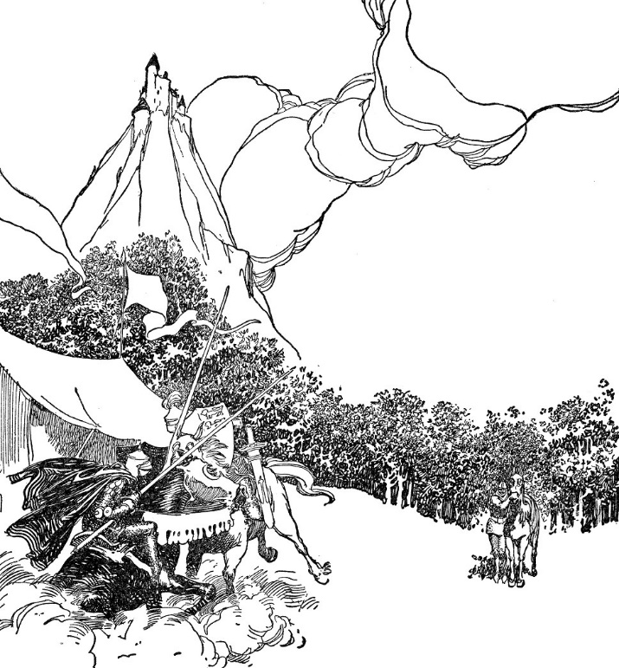

tournaments, and similar spectacles. Those spending significant amounts of money in this Special Interest are actually sponsoring games and other events (which will, in the grand tradition of bread and circuses, most likely make them quite popular with the populace).

Philanthropy: The creation or support of private initiatives for the public good. Orphanages, libraries, public hospitals, children’s charities, education programs, almshouses, establishing public infrastructure, the Continual Light Streetlight Foundation, the Spectral Society, the Circle for the Succor of Bereft Familiars, or any number of other possibilities exist.

Religion: Generally tithing or, depending on the faith in question, the purchase of actual sacrifices to be offered to the gods (fatted calfs and so forth).

For purely monetary tithing, the normal community GP limit does not apply. (The church will happily take all the money you choose to give to it.) However, unusually large donations risk attracting the attention of the gods. (And not always the god you were looking to appease!) Roll an additional complication check for each multiple of the community GP limit donated. (For example, if the GP limit is 100 GP and you donate 350 GP, you would roll four complication checks – the normal one, but one additional check for exceeding 100, 200, and 300 GPs.)

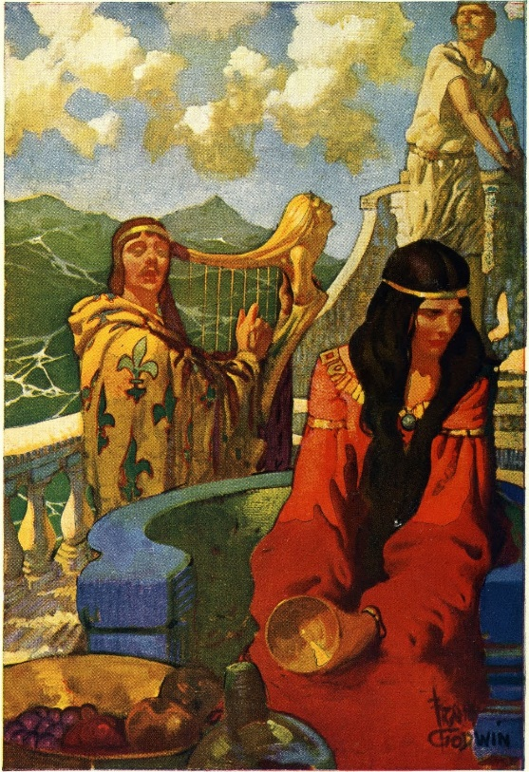

Song/Fame: Expenditures in this Special Interest represent a character’s efforts to increase their fame or notoriety. Sponsoring bards to compose and perform songs of their deeds, publishing personal memoirs, and so forth.

In addition to the normal community GP limit, expenditures in this category are limited to 100 GP per delve/adventure the character has participated in. (The bards can only do so much with limited material.)

Training: Wealth spent in this Special Interest simply represents paying for expert training and/or training equipment. In order to train most effectively, a character must have access to a sufficiently skilled trainer. (Any character with a higher level in the same class is considered such automatically, but at the GM’s discretion some teachers may be capable of effectively training those better than themselves.) If such a trainer is not available, expenditures in this Special Interest only generate half the normal amount of XP.

Hoarding: When hoarding gold pieces, you simply stash them away. If your hoard is ever lost, stolen, or you’re forced to spend your stash, however, it creates an XP deficit equal to the XP gained from hoarding the gold in the first place. This won’t cause the character to lose levels, but they’ll need to pay off the XP deficit before accruing more.

* + Complication: 1 in 20 chance per quiescence that something threatens the hoard.

Hobbies: The Hobby category covers a wide variety of different activities. Most characters will generally focus on one or two hobbies, however, and players should give some thought to what they are. GPs spent in Hobbies can be used for hobby equipment (as long as that equipment does not have an adventuring application), but is more likely to be spent contributing to the completion of projects.

* + Sample Hobbies: Creature Husbandry (Growth, Breeding, Control, Increasing Intelligence, Magical Alterations, Frankensteinian Experiments), Robotic Tinkering, Device Creation/Improvement, Languages, Brewing, Hunting, Art, Spell Research, Item Creation
  + Defining Projects: When a character proposes a project (breeding a hydra with more heads, creating a series of commemorative sculptures dedicated to dead heroes, writing and printing several hundred copies of a political manifesto) the GM defines that project in terms of a progress clock (a circle divided in 4, 6, or 8 segments, with larger numbers of segments representing more difficult projects), a GP cost per segment, and an appropriate ability score that can be used to work on the project.
  + Completing Projects: Once per quiescence, the character can spend GPs equal to the cost of one or more project segments and attempt to advance the project by making an ability score check. Each additional segment they are attempting to complete past the first applies a -1 penalty to this check. If the check is successful, they can fill in the number of segments they were working on. If the check fails, no segments are filled in. In either case, they spend the GPs and gain XP accordingly. If all of the segments in the project’s progress clock are filled in, the project has been completed.
  + Special Materials: At the GM’s discretion, some projects (or project segments) may require specific special materials which can only be acquired through questing in order to complete them.
  + Arcane Projects: See below.
  + Complication: 1 in 6 when attempting to complete a project.

RACIAL SPECIAL INTERESTS

Human – Generalist: Roll 1d8 to determine a second random Special Interest. (If you roll the same result, re-roll until you get a different result.) This Special Interest is also rated at 100%.

Dwarven Clan Hoards: Each dwarven clan maintains a hoard. The size of a clan’s hoard determines its prestige, political power, mining rights, bearding patents, and other cultural cachet. A dwarf can donate money to their clan hoard as a Special Interest. There are no withdrawals from a clan hoard(unless the clan is in a truly precarious state), so any money so donated is “lost” to the character.

* + There is no limit to the amount of money that can be donated to the clan hoard, but it must be sent to the hoard via caravan.
  + Roll 2d6+3 x 10% to determine the dwarf’s rating in this Special Interest.

Elven Tree Offerings: Throughout their long lives, elves will craft small spirit totems. (Roughly the size of your hand.) Many will carve simple wooden figures, but those who can afford to do so will create elaborate totems made from rare metals, precious gems, unusual alchemicals, and the like. Each of these totems is left at the foot of a tree, and elves believe that these trees will guide them to the afterlife. Some believe that dryads are born from these spirit totems; gestalt spirits formed from the eldritch patchwork of the myriad elven soul shards left within the totems.

* + The amount of money which can be spent on an individual spirit totem is limited by the community’s GP limit, but gemstones (and other appropriate substances subject to the GM’s approval) can be “spent” above this limit by incorporating them into the totem’s design. (This money can be spent on a single spirit totem or split across multiple, more modest spirit totems.)
  + Elves automatically have a 100% rating in this Special Interest. However, if they place their spirit totem at the base of a particularly sacred or powerful tree (usually requiring a pilgrimage to distant lands or a quest of some sort) the GM can award a bonus of +10% to +50% depending on the potency or significance of the tree in question.
  + Elves can only meaningfully place one spirit totem per tree.

Hobbit Gifting: Hobbits build community through gift-giving. They throw gifting parties at which they give away gifts to all of the invited guests. Traditionally each gift must be hand labeled, with the papers and inks selected having various ceremonial and coded meanings.

* + Once per year, hobbits can throw a gifting party on their birthday. (Determine the date randomly.) On this special occasion, they gain twice the normal amount of XP per GP spent on gifts.
  + 20% of the total value of gifts given at a gifting party can be given to other PCs. (Additional gifts can be given in excess of this, but their cost will not grant XP.)
  + Hobbits determine their rating in this Special Interest normally (2d6 x 10%).

ARCANE PROJECTS

XP for Arcane Projects: Generally speaking, any project which actually creates an item (spell egg, magic sword, etc.) will not grant XP. (It’s just like money spent to purchase any other adventuring equipment.) Creating plans, researching spells, and even building workshops, on the other hand, all grant XP.

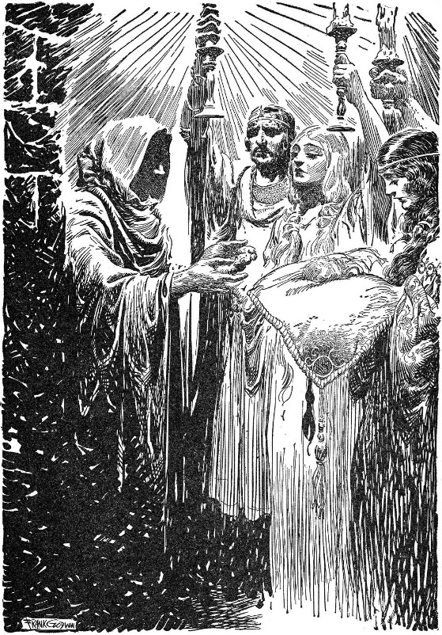

Prime Requisite Tests: Arcane projects generally use the caster’s prime requisite score.

Spell Formula: These plans allow one to both make spell eggs and copy out derivative rites into a personal spellbook (thus learning how to cast the spell).

* + Deciphering Amulets: Amulets are ancient technomantic artifacts and they serve as the template on which most modern magic is based. Studying an amulet with the appropriate effect makes it considerably easier to derive the spell formula. This project uses a special progress clock with a number of segments equal to ½ the spell level (round up) and costs 100 gp per segment.
  + Original Spell Research: The precise nature and level of an original spell must be approved by the GM. Performing the research uses a special progress clock with a number of segments equal to the spell level and costs 1,000 x the spell level per segment.

Bespoke Spell Eggs: If you have the appropriate spell formula, you can create one-off, handmade spell eggs as a project. Use a special progress clock with a number of segments equal to the spell level. Each segment costs 100 GP.

Workshops: Workshops are automated facilities which can produce spell eggs. They are imperfect copies of the sophisticated Laboratories of the Ancients. Each workshop is capable of producing one specific type of spell egg.

* + Creating Workshop Plans: It is necessary to possess or create plans for a workshop before one can be built. If one has access to an appropriate Laboratory, reverse engineering its mechanisms in order to create workshop plans for one type of spell egg uses a special progress clock with a number of segments equal to 5 + the spell level and costs 100 GP x the spell level per segment. Creating completely original workshop plans can be incredibly difficult, requiring a number of segments equal to 5 + the spell level squared.
  + Building a Workshop: Once you have appropriate plans, building a workshop uses a special progress clock with a number of segments equal to 5 + the spell level squared and costs 1,000 GP x the spell level per segment.

Workshop/Laboratory Spell Eggs: A workshop or laboratory will produce one spell egg per week, as long as it is supplied with raw materials equal to 100 GP x the spell level. The machines of the ancients are more efficient, and laboratories only require 80 GP x the spell level to produce a spell egg.

Other Magic Item Plans: In order to create a magic item, one must first either possess or create the plans for it. (A technical manual is sufficient for this purpose.) The difficulty and expense of creating these plans is defined by the GM, as is the difficulty and expense of creating the item itself. Some magic items may require special materials. (For example, capturing a demon’s soul to place within an amulet.)

STRONGHOLDS

Specific rules for establishing and managing strongholds are beyond this present document, but 100% of GP spent on strongholds grant XP. If strongholds are located within the community, 50% of these expenses are also considered community investment.

THINGS THAT WOULD BE NICE TO ADD TO THIS SYSTEM

* + A random table for determining Caravan mishaps.
  + A more fully-developed Caravan [game structure](https://thealexandrian.net/wordpress/15126/roleplaying-games/game-structures). If players become invested in the caravan process at an open table, you could easily have one section of the campaign become entirely devoted to characters running/guarding caravans.
  + A system for managing population growth. As investment in the local community swells, new people will be attracted to the settlement.
  + A system for damaging a community’s GP limit (sacking a town, natural disaster, etc.).
  + Earning profits from your investments when other PCs spend money on those Special Interests.
  + Detailed complication tables for each Special Interest. For Carousing you can check out Jeff Rients’ [Party Like It’s 999](https://jrients.blogspot.com/2008/12/party-like-its-999.html), Colin Chapman’s [Drunken Debauchery!](http://www.hyperborea.tv/uploads/4/4/6/6/44662451/drunken_debauchery.pdf), and Claytonian JP’s [DCC Montage Rules](http://killitwithfirerpg.blogspot.com/2014/06/xp-for-gold-revision-100-montage.html).

Джерело: <<https://thealexandrian.net/wordpress/40950/roleplaying-games/running-castle-blackmoor-part-9-special-interests>>

v [Running Castle Blackmoor – Part 9: Special Interests](https://thealexandrian.net/wordpress/40950/roleplaying-games/running-castle-blackmoor-part-9-special-interests)

October 22nd, 2018

[Go to Part 1](https://thealexandrian.net/wordpress/40789/roleplaying-games/running-castle-blackmoor) – [Go to Special Interest Rules](https://thealexandrian.net/wordpress/40942/roleplaying-games/running-castle-blackmoor-part-8-special-interest-experience)



Carousing: Includes drinking, gambling, lusting, entertainment, drugs, fine dining, and all manner of merriment. A good carousing can last the better part of a week. Characters with high Constitution scores can keep going longer than their comrades. When rolling for the community’s carousing GP limit, add a bonus to the die roll based on the character’s Constitution (13-15: +1, 16-17: +2, 18: +4).

Complication: Carousing requires a save vs. poison. On a failure, roll a complication.

Carnavale: The money expended here goes towards enjoying gladiator duels, races (chariot, griffon, etc.), masques, festivals, parades, triumphs, jousting



tournaments, and similar spectacles. Those spending significant amounts of money in this Special Interest are actually sponsoring games and other events (which will, in the grand tradition of bread and circuses, most likely make them quite popular with the populace).

Philanthropy: The creation or support of private initiatives for the public good. Orphanages, libraries, public hospitals, children’s charities, education programs, almshouses, establishing public infrastructure, the Continual Light Streetlight Foundation, the Spectral Society, the Circle for the Succor of Bereft Familiars, or any number of other possibilities exist.

Religion: Generally tithing or, depending on the faith in question, the purchase of actual sacrifices to be offered to the gods (fatted calfs and so forth).

For purely monetary tithing, the normal community GP limit does not apply. (The church will happily take all the money you choose to give to it.) However, unusually large donations risk attracting the attention of the gods. (And not always the god you were looking to appease!) Roll an additional complication check for each multiple of the community GP limit donated. (For example, if the GP limit is 100 GP and you donate 350 GP, you would roll four complication checks – the normal one, but one additional check for exceeding 100, 200, and 300 GPs.)



Song/Fame: Expenditures in this Special Interest represent a character’s efforts to increase their fame or notoriety. Sponsoring bards to compose and perform songs of their deeds, publishing personal memoirs, and so forth.

In addition to the normal community GP limit, expenditures in this category are limited to 100 GP per delve/adventure the character has participated in. (The bards can only do so much with limited material.)

Training: Wealth spent in this Special Interest simply represents paying for expert training and/or training equipment. In order to train most effectively, a character must have access to a sufficiently skilled trainer. (Any character with a higher level in the same class is considered such automatically, but at the GM’s discretion some teachers may be capable of effectively training those better than themselves.) If such a trainer is not available, expenditures in this Special Interest only generate half the normal amount of XP.

Hoarding: When hoarding gold pieces, you simply stash them away. If your hoard is ever lost, stolen, or you’re forced to spend your stash, however, it creates an XP deficit equal to the XP gained from hoarding the gold in the first place. This won’t cause the character to lose levels, but they’ll need to pay off the XP deficit before accruing more.

* + Complication: 1 in 20 chance per quiescence that something threatens the hoard.

Hobbies: The Hobby category covers a wide variety of different activities. Most characters will generally focus on one or two hobbies, however, and players should give some thought to what they are. GPs spent in Hobbies can be used for hobby equipment (as long as that equipment does not have an adventuring application), but is more likely to be spent contributing to the completion of projects.

* + Sample Hobbies: Creature Husbandry (Growth, Breeding, Control, Increasing Intelligence, Magical Alterations, Frankensteinian Experiments), Robotic Tinkering, Device Creation/Improvement, Languages, Brewing, Hunting, Art, Spell Research, Item Creation
  + Defining Projects: When a character proposes a project (breeding a hydra with more heads, creating a series of commemorative sculptures dedicated to dead heroes, writing and printing several hundred copies of a political manifesto) the GM defines that project in terms of a progress clock (a circle divided in 4, 6, or 8 segments, with larger numbers of segments representing more difficult projects), a GP cost per segment, and an appropriate ability score that can be used to work on the project.
  + Completing Projects: Once per quiescence, the character can spend GPs equal to the cost of one or more project segments and attempt to advance the project by making an ability score check. Each additional segment they are attempting to complete past the first applies a -1 penalty to this check. If the check is successful, they can fill in the number of segments they were working on. If the check fails, no segments are filled in. In either case, they spend the GPs and gain XP accordingly. If all of the segments in the project’s progress clock are filled in, the project has been completed.
  + Special Materials: At the GM’s discretion, some projects (or project segments) may require specific special materials which can only be acquired through questing in order to complete them.
  + Arcane Projects: See below.
  + Complication: 1 in 6 when attempting to complete a project.

RACIAL SPECIAL INTERESTS

Human – Generalist: Roll 1d8 to determine a second random Special Interest. (If you roll the same result, re-roll until you get a different result.) This Special Interest is also rated at 100%.

Dwarven Clan Hoards: Each dwarven clan maintains a hoard. The size of a clan’s hoard determines its prestige, political power, mining rights, bearding patents, and other cultural cachet. A dwarf can donate money to their clan hoard as a Special Interest. There are no withdrawals from a clan hoard(unless the clan is in a truly precarious state), so any money so donated is “lost” to the character.

* + There is no limit to the amount of money that can be donated to the clan hoard, but it must be sent to the hoard via caravan.
  + Roll 2d6+3 x 10% to determine the dwarf’s rating in this Special Interest.

Elven Tree Offerings: Throughout their long lives, elves will craft small spirit totems. (Roughly the size of your hand.) Many will carve simple wooden figures, but those who can afford to do so will create elaborate totems made from rare metals, precious gems, unusual alchemicals, and the like. Each of these totems is left at the foot of a tree, and elves believe that these trees will guide them to the afterlife. Some believe that dryads are born from these spirit totems; gestalt spirits formed from the eldritch patchwork of the myriad elven soul shards left within the totems.

* + The amount of money which can be spent on an individual spirit totem is limited by the community’s GP limit, but gemstones (and other appropriate substances subject to the GM’s approval) can be “spent” above this limit by incorporating them into the totem’s design. (This money can be spent on a single spirit totem or split across multiple, more modest spirit totems.)
  + Elves automatically have a 100% rating in this Special Interest. However, if they place their spirit totem at the base of a particularly sacred or powerful tree (usually requiring a pilgrimage to distant lands or a quest of some sort) the GM can award a bonus of +10% to +50% depending on the potency or significance of the tree in question.
  + Elves can only meaningfully place one spirit totem per tree.

Hobbit Gifting: Hobbits build community through gift-giving. They throw gifting parties at which they give away gifts to all of the invited guests. Traditionally each gift must be hand labeled, with the papers and inks selected having various ceremonial and coded meanings.

* + Once per year, hobbits can throw a gifting party on their birthday. (Determine the date randomly.) On this special occasion, they gain twice the normal amount of XP per GP spent on gifts.
  + 20% of the total value of gifts given at a gifting party can be given to other PCs. (Additional gifts can be given in excess of this, but their cost will not grant XP.)
  + Hobbits determine their rating in this Special Interest normally (2d6 x 10%).

ARCANE PROJECTS

XP for Arcane Projects: Generally speaking, any project which actually creates an item (spell egg, magic sword, etc.) will not grant XP. (It’s just like money spent to purchase any other adventuring equipment.) Creating plans, researching spells, and even building workshops, on the other hand, all grant XP.



Prime Requisite Tests: Arcane projects generally use the caster’s prime requisite score.

Spell Formula: These plans allow one to both make spell eggs and copy out derivative rites into a personal spellbook (thus learning how to cast the spell).

* + Deciphering Amulets: Amulets are ancient technomantic artifacts and they serve as the template on which most modern magic is based. Studying an amulet with the appropriate effect makes it considerably easier to derive the spell formula. This project uses a special progress clock with a number of segments equal to ½ the spell level (round up) and costs 100 gp per segment.
  + Original Spell Research: The precise nature and level of an original spell must be approved by the GM. Performing the research uses a special progress clock with a number of segments equal to the spell level and costs 1,000 x the spell level per segment.

Bespoke Spell Eggs: If you have the appropriate spell formula, you can create one-off, handmade spell eggs as a project. Use a special progress clock with a number of segments equal to the spell level. Each segment costs 100 GP.

Workshops: Workshops are automated facilities which can produce spell eggs. They are imperfect copies of the sophisticated Laboratories of the Ancients. Each workshop is capable of producing one specific type of spell egg.

* + Creating Workshop Plans: It is necessary to possess or create plans for a workshop before one can be built. If one has access to an appropriate Laboratory, reverse engineering its mechanisms in order to create workshop plans for one type of spell egg uses a special progress clock with a number of segments equal to 5 + the spell level and costs 100 GP x the spell level per segment. Creating completely original workshop plans can be incredibly difficult, requiring a number of segments equal to 5 + the spell level squared.
  + Building a Workshop: Once you have appropriate plans, building a workshop uses a special progress clock with a number of segments equal to 5 + the spell level squared and costs 1,000 GP x the spell level per segment.

Workshop/Laboratory Spell Eggs: A workshop or laboratory will produce one spell egg per week, as long as it is supplied with raw materials equal to 100 GP x the spell level. The machines of the ancients are more efficient, and laboratories only require 80 GP x the spell level to produce a spell egg.

Other Magic Item Plans: In order to create a magic item, one must first either possess or create the plans for it. (A technical manual is sufficient for this purpose.) The difficulty and expense of creating these plans is defined by the GM, as is the difficulty and expense of creating the item itself. Some magic items may require special materials. (For example, capturing a demon’s soul to place within an amulet.)

STRONGHOLDS

Specific rules for establishing and managing strongholds are beyond this present document, but 100% of GP spent on strongholds grant XP. If strongholds are located within the community, 50% of these expenses are also considered community investment.

THINGS THAT WOULD BE NICE TO ADD TO THIS SYSTEM

* + A random table for determining Caravan mishaps.
  + A more fully-developed Caravan [game structure](https://thealexandrian.net/wordpress/15126/roleplaying-games/game-structures). If players become invested in the caravan process at an open table, you could easily have one section of the campaign become entirely devoted to characters running/guarding caravans.
  + A system for managing population growth. As investment in the local community swells, new people will be attracted to the settlement.
  + A system for damaging a community’s GP limit (sacking a town, natural disaster, etc.).
  + Earning profits from your investments when other PCs spend money on those Special Interests.
  + Detailed complication tables for each Special Interest. For Carousing you can check out Jeff Rients’ [Party Like It’s 999](https://jrients.blogspot.com/2008/12/party-like-its-999.html), Colin Chapman’s [Drunken Debauchery!](http://www.hyperborea.tv/uploads/4/4/6/6/44662451/drunken_debauchery.pdf), and Claytonian JP’s [DCC Montage Rules](http://killitwithfirerpg.blogspot.com/2014/06/xp-for-gold-revision-100-montage.html).

Джерело: <<https://thealexandrian.net/wordpress/40950/roleplaying-games/running-castle-blackmoor-part-9-special-interests>>

[Running Castle Blackmoor – Part 10: Blackmoor Village Map](https://thealexandrian.net/wordpress/41187/roleplaying-games/running-castle-blackmoor-part-10-blackmoor-village-map)

November 14th, 2018

[Go to Part 1](https://thealexandrian.net/wordpress/40789/roleplaying-games/running-castle-blackmoor)

In running my remixed version of Castle Blackmoor, I knew that the village of Blackmoor at the foot of the castle would become quite important. I printed out copies of some of the earliest maps of Blackmoor created by Arneson, but quickly discovered in actual play that they had not been made available at legible resolutions. With a little bit of research you could sort of figure things out, but the map ultimately proved more confusing than illuminating to most of my players.

What I needed was a copy of the map at a higher resolution so that I could print it out, put it in my GM screen, and have it be clearly visible to players at the opposite end of the table. On the other hand, I didn’t want to radically depart from Arneson’s original material. So what I ended up doing, basically, was redrawing the entire map.

The map above is based on this map from Domesday Book #13:

An even older version of this map was made available on [Havard’s Blackmoor blog](http://blackmoormystara.blogspot.com/2017/02/blackmoor-town-maps-by-dave-arneson.html):

There were a few places where I was tempted to make alterations/corrections. But I ultimately decided to remain as true to this original map as possible. (There is exactly one exception to this, and it shouldn’t be too hard to spot.)

For the version given to my players, however, I did decide to roll the clock back: Jenkins Hill is not yet (and may never be) Jenkins Hill in this version of Blackmoor, nor has the Great Svenny built his freehold. So this will be the version of the map I give to my players:

You can click either of these maps to download high resolution copies.

Джерело: <<https://thealexandrian.net/wordpress/41187/roleplaying-games/running-castle-blackmoor-part-10-blackmoor-village-map>>